**Instagram User Analytics**

**Project Description :**

As per the initial project report , I have been assigned the job to gather & provide insights to

the product team of Instagram based on the questions they have asked. We have to work on

the data from the provided database and collect useful insights for Instagram to launch

appropriate marketing campaigns.

**The questions on which they require insights are :**

**A) Marketing:** The marketing team wants to launch some campaigns, and they need your

help with the following :

1. Rewarding Most Loyal Users: People who have been using the platform for the longest time.

Your Task: Find the 5 oldest users of the Instagram from the database provided

2. Remind Inactive Users to Start Posting: By sending them promotional emails to post their 1st photo.

Your Task: Find the users who have never posted a single photo on Instagram

3. Declaring Contest Winner: The team started a contest and the user who gets the most likes on a single photo will win the contest now they wish to declare the winner.

Your Task: Identify the winner of the contest and provide their details to the team

4. Hashtag Researching: A partner brand wants to know, which hashtags to use in the post to reach the most people on the platform.

Your Task: Identify and suggest the top 5 most commonly used hashtags on the platform

5. Launch AD Campaign: The team wants to know, which day would be the best day to launch ADs.

Your Task: What day of the week do most users register on? Provide insights on when to schedule an ad campaign

**B) Investor Metrics:** Our investors want to know if Instagram is performing well and is not becoming redundant like Facebook, they want to assess the app on the following grounds

1. User Engagement: Are users still as active and post on Instagram or they are making fewer posts

Your Task: Provide how many times does average user posts on Instagram. Also, provide the total number of photos on Instagram/total number of users

2. Bots & Fake Accounts: The investors want to know if the platform is crowded with fake and dummy accounts

Your Task: Provide data on users (bots) who have liked every single photo on the site

(since any normal user would not be able to do this).

**Approach**

To perform the required tasks and complete the project , I have used SQL queries using MySQL Workbench. According to the instructions provided to create the database and the corresponding tables, I feeded the data into MySQL and executed the appropriate queries to get the required insights.

**Tech Stack Used**

1. MySQL Workbench 8.0 CE (Commandline client)

2. Microsoft Word (Office 365)

**Insights**

Since, I already had a brief hands on experience with SQL in my Bachelor’s degree curriculum, but it was only basic concepts which I had worked with . This Instagram user analytics project helped me to dig deeper into the world of SQL and helped me understand how complex queries work and how to cultivate business insights from given data. It enabled me to ask the right necessary questions and narrow down solutions to the given problems.

**Results**

Here are the query statements which I executed and the corresponding results.

SQL Tasks:

**A) Marketing Analysis:**

1. **Loyal User Reward:** The marketing team wants to reward the most loyal users, i.e., those who have been using the platform for the longest time.  
   Your Task: Identify the five oldest users on Instagram from the provided database.

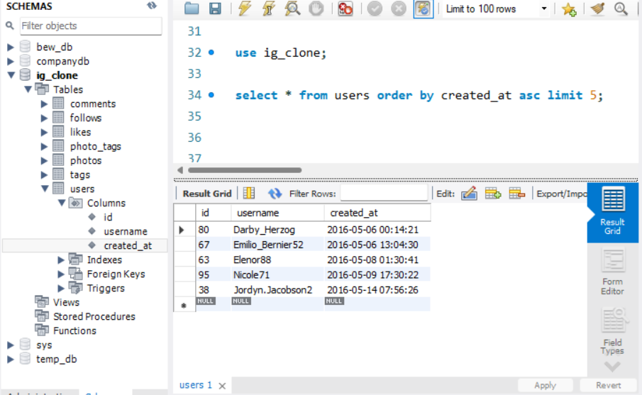

1. **Inactive User Engagement:** The team wants to encourage inactive users to start posting by sending them promotional emails.  
   Your Task: Identify users who have never posted a single photo on Instagram.

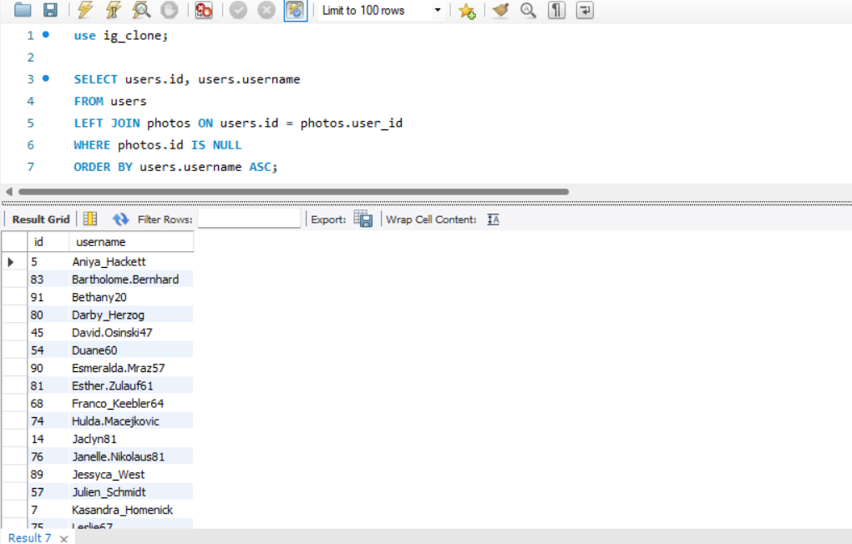

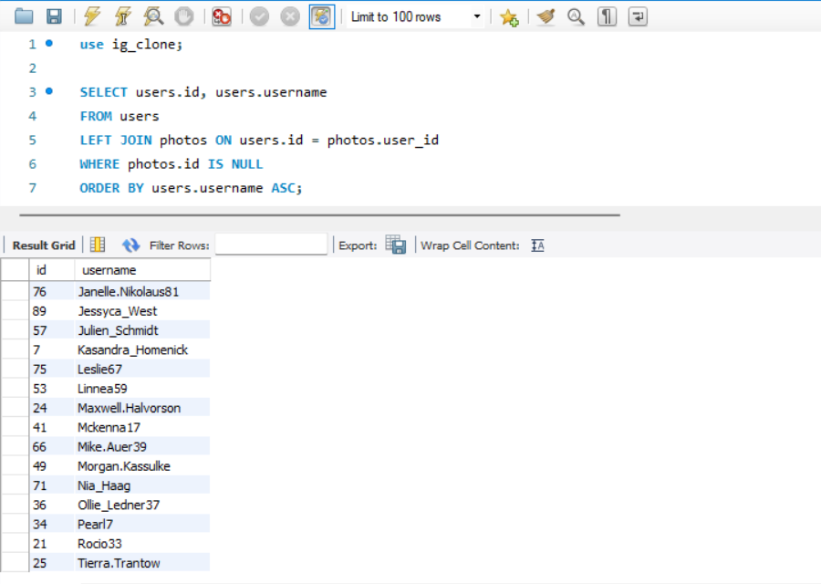

1. **Contest Winner Declaration:** The team has organized a contest where the user with the most likes on a single photo wins.  
   Your Task: Determine the winner of the contest and provide their details to the team.

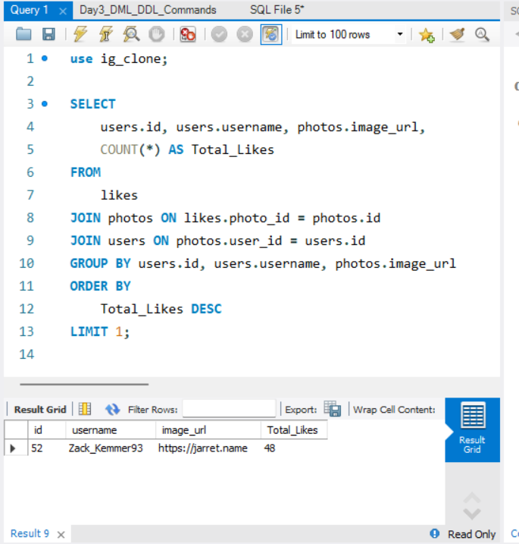

1. **Hashtag Research:** A partner brand wants to know the most popular hashtags to use in their posts to reach the most people.  
   Your Task: Identify and suggest the top five most commonly used hashtags on the platform.

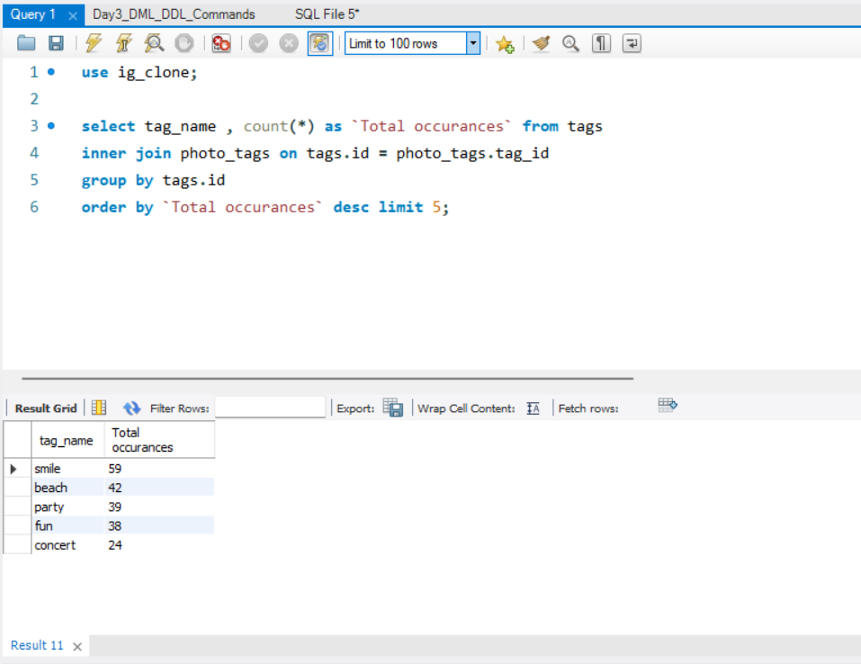

1. **Ad Campaign Launch:** The team wants to know the best day of the week to launch ads.  
   Your Task: Determine the day of the week when most users register on Instagram. Provide insights on when to schedule an ad campaign.

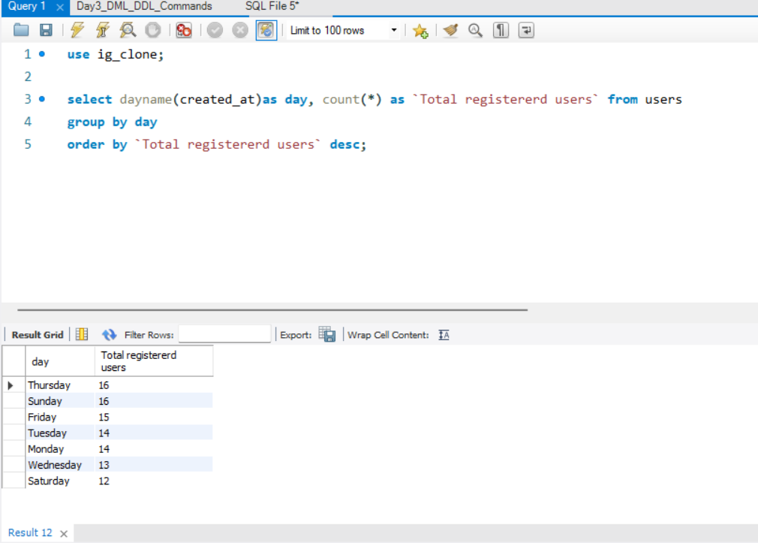

**B) Investor Metrics:**

1. **User Engagement:** Investors want to know if users are still active and posting on Instagram or if they are making fewer posts.  
   Your Task: Calculate the average number of posts per user on Instagram. Also, provide the total number of photos on Instagram divided by the total number of users.

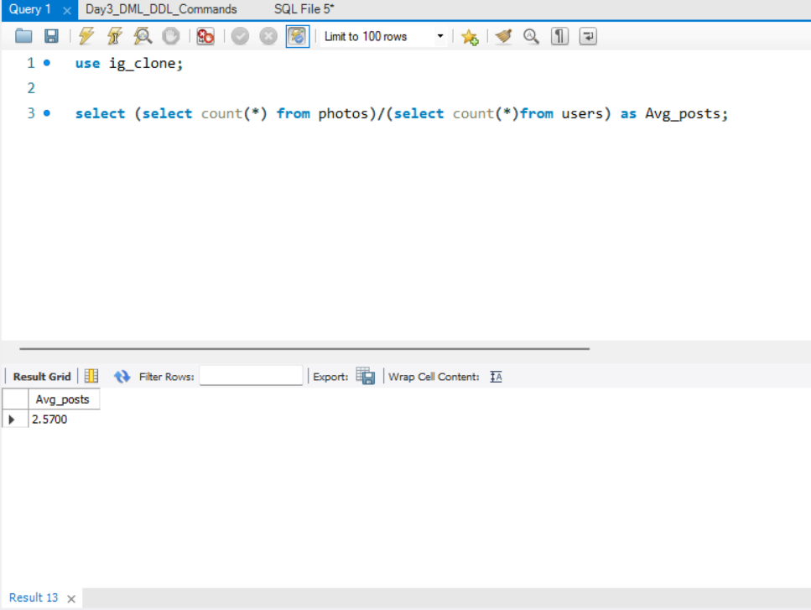

1. **Bots & Fake Accounts:** Investors want to know if the platform is crowded with fake and dummy accounts.  
   Your Task: Identify users (potential bots) who have liked every single photo on the site, as this is not typically possible for a normal user.

